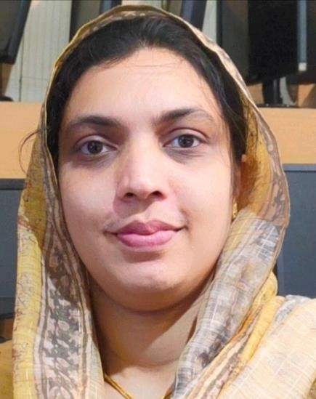
RAHITHA K
Assistant Professor
Department of Artificial Intelligence and Data Science rahithaashraf@gmail.com

Educational Background
- M.Tech in Computer Science and Engineering from University of Calicut (2016)
- B.Tech in Computer Science and Engineering from University of Calicut (2011)

Professional Experience
- 4 years of experience as Assistant professor in JDT Islam College of Arts and Science
- 1 year of experience at HHM JDT Islam polytechnic college
- 2 years of experience as junior programmer in Kelappaji Agricultural engineering college,Kuttipuram

Area of Interest
- Artificial Intelligence & Machine Learning
- Data Science

Area of Expertise
- Data structures and algorithm
- Computer Networks
- Design and Analysis of Algorithms
- Database Management Systems
- Computer organisation and architecture
- Programming

Hobbies
- Reading
- Travelling

For professional inquiries or collaborations, contact via email: r a h i t h a a s h r a f @ g m a i l . c o m

