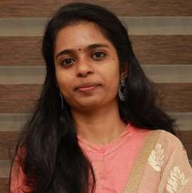
ASHWINI
Assistant Professor
Department of Computer Applications ashwini96suresh@gmail.com

Educational Background
- Master of Computer Applications from KMCT College of Engineering (2021)
- Bachelor of computer Applications from Global College of Engineering(2018)

Professional Experience
- 6 month of experience as Higher Secondary Teacher at St.Joseph English medium School Puthanangadi Perinthalmanna(May 2022 onwars).

- Nearly 2 year experience as Assistant Professor at AWH Engineering College Kuttikkattoor(November 2022 Onwards) in Master of Computer Applications Department.

Area of Interest
- Cyber Security
- Cryptography
- Artificial Intelligence & Machine Learning

Area of Expertise
- Artificial Intelligence
- Web programming
- Database Management
- Android

Hobbies
- Dancing

For professional inquiries or collaborations, contact via email:ashwini@kmctceet.org

