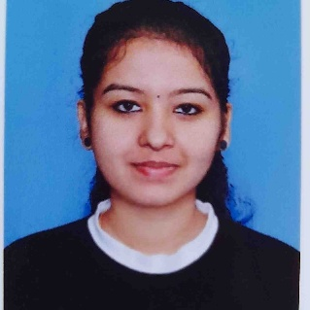
ARCHITHA K K
Assistant Professor
Department of Electronics and Communication Engineering
archithanambiar3@gmail.com

Educational Background
- Masters of Technology in Signal Processing and Embedded System from APJ Abdul Kalam Technological University
- Bachelors of Technology in Electronics and Communication Engineering from APJ Abdul Kalam Technological University

Area of Interest
- Digital Electronics
- Embedded Systems and VLSI

Area of Expertise
- Signal Processing
- Embedded system
- Chip designing
- Micro Processors and Micro Controllers

Hobbies
- Reading
- Singing
- Drawing and Dancing

