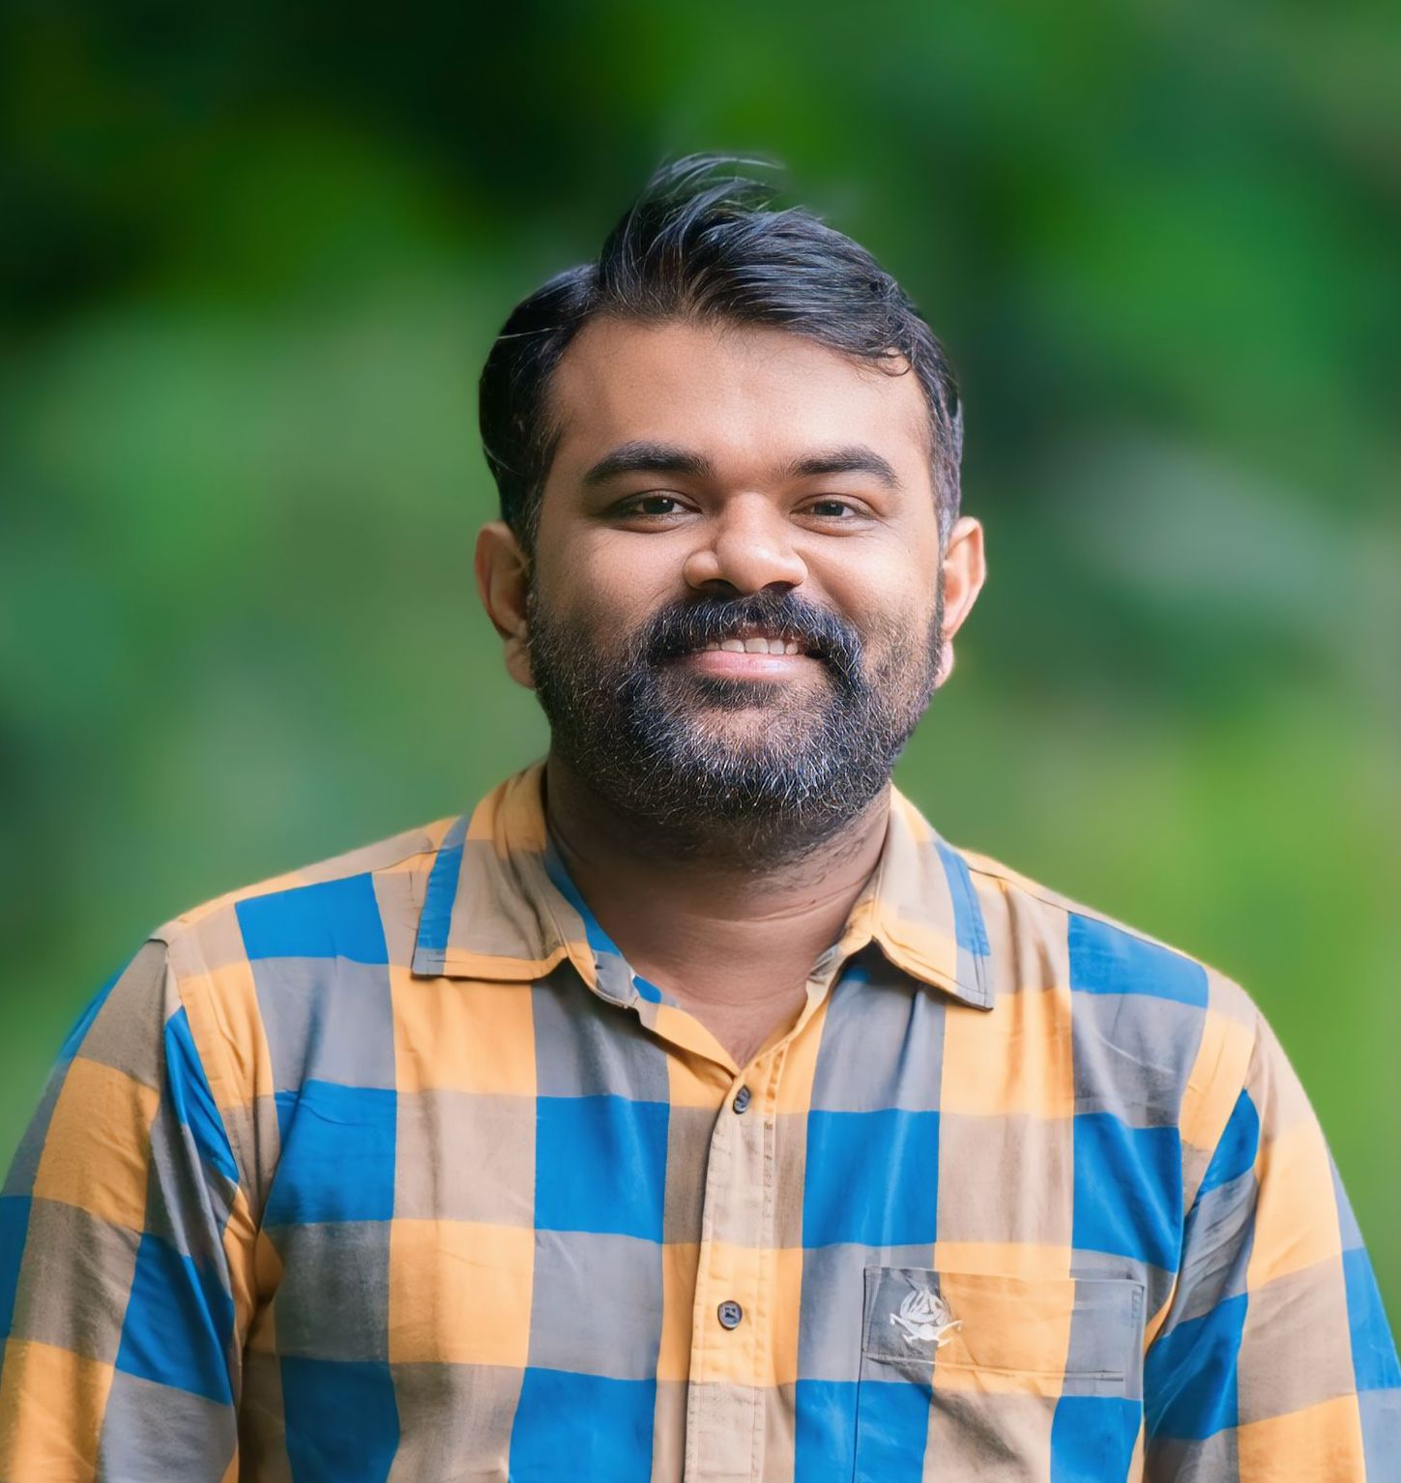
JIBIN EP
Assistant Professor
Department of Electronics and Communication Engineering
epjibin@gmail.com

Educational Background
Ph.D. (Research Scholar – Ongoing)
Year: 2023 to Present
Institution: Noorul Islam College of Higher Education (NICHE), Kanyakumari
Topic: Machine Learning-Driven Solutions for Early Detection of Cardiac Disorders
M.E. – Applied Electronics
Year: 2013–2015
University: Anna University
College: JKK Munirajah College of Technology, Tamil Nadu
B.E. – Electronics and Communication Engineering
Year: 2007–2011
University: Anna University
College: Sasurie College of Engineering, Tamil Nadu

Professional Experience

1. Assistant Professor (9 Years)
Eranad Knowledge City Technical Campus, Manjeri, Kerala
Duration: 2016 – 2025

2. Lecturer – Electronics (2 Years)
Govt. Women's Polytechnic College, Kottakkal
Duration: 2012–2013, 2015–2016

3. Lecturer – Electronics (Regular & Evening) (3 Years)
AKNM Govt. Polytechnic College, Chelari
Duration: 2015–2018 (Evening Batch)

4. Co-Founder & Director
Shastra Technical Institute & Engineering Learning App (Online Coaching Centre)
Duration: 2016 – Present

5. Managing Partner
New Ampere Technologies (Electronics Contracting Company)
Duration: 2021 – Present

Area of Interest
- Digital & Analog Circuits Design
- Microcontrollers & Embedded Systems
- Communication Systems
- Electronic Devices & Semiconductor Physics
- Circuit Simulation and Analysis (MATLAB, SPICE)
- IoT and Embedded Systems Integration

Area of Expertise
- Teaching Electronics & Communication Engineering subjects
- Digital and Analog Circuits, Communication Systems, VLSI, Microcontrollers
- Educational Technology Integration & Mobile Learning Platforms
- Content Creation for EdTech (YouTube & Learning Apps)
- Academic Research & Data Interpretation

Hobbies
- Content creation for YouTube and mobile learning apps
- Reading research articles and technical blogs
- Public speaking and seminar presentations
- Exploring EdTech innovations
- Traveling and photography
- Participating in tech forums and webinars

