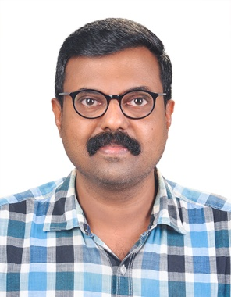 | SOORAJ S  Assistant Professor  Department of Electronics and Communication Engineering  soorajsruthi@gmail.com

Educational Background
- M.E. in VLSI Design from Anna University (2004)
- B.Tech in Electronics and Communication Engineering from Calicut University (2002)
Professional Experience
- 5 years of experience as Senior Lecturer at Amrita School of Engineering, Coimbatore
- 5 years of experience as Assistant Professor at KMCT College of Engineering for Women, Kozhikode
- 9 years of experience as Assistant Professor at M Dasan Institute of Technology, Kozhikode
Area of Interest
- Biomedical Signal Processing
- Robotics
- Embedded Systems
- Artificial Intelligence
Area of Expertise
- Control Systems
- Digital Signal Processing
- Logic Circuit Design
- Computer Architecture and Microcontrollers
- Network Theory
- Linear Integrated Circuits
- Embedded Systems
- Programming in C
- VLSI Design using Verilog HDL
Hobbies
- Listening to music
- Photography
- Poster designing

